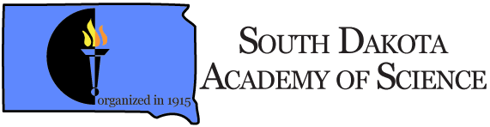

For the Promotion of Science Teaching, Research and Service

http://www.sdaos.org

2023 Form for New Members and Renewal of Continuing Members
All memberships are for a calendar year (January 1 to December 31)

Name________________________________________________________________________
Institution/Agency ___________________________ Department or Area__________________
Mailing Address_______________________________________________________________
City ____________________________ State ________________ Zip ____________________
Telephone (business) (____)_________________ E-mail______________________________
Renewing Member ( ) New Member ( ) Life Members¹ (address update) ( )
Please check the appropriate membership category:
- Student Membership - $10 annually
(High School, Undergraduate, or Graduate Students)

- High School Teachers - $10 annually

- Full Members - $25 annually

TOTAL AMOUNT ENCLOSED………………………$______________

Payment may be made through the SDAS website via PayPal (https://sdaos.org/membership/), or send payment (check or money order) by US mail to:
Dr. Jeff Palmer, Treasurer, South Dakota Academy of Science
College of Arts and Sciences-SC
Dakota State University, 820 N. Washington Ave.
Madison SD 57042

¹Note: Fellows of the South Dakota Academy of Science are Life Members and are not required to pay annual dues. For headcount and purposes of record keeping, we request that Fellows/Life Members fill out a Membership Renewal form but not send payment.

